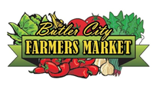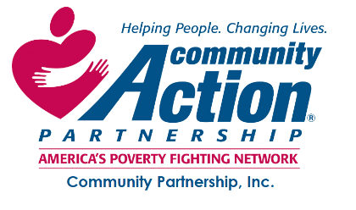

2022 Fresh Bucks Program Application
Fresh Bucks is a nutrition incentive program offered by Community Partnership, Inc. in partnership with the Butler City Farmer’s Market and ANR Transport. Fresh Bucks are coupons that are redeemable for fresh fruits and vegetables at the Butler City Farmer’s Market.
Contact Information: Application Date:__________
Name:________________________________________________________________________
Street Address: _________________________________________________________________
City: _________________________________ State: _______________ Zip Code: ___________
Email Address: _________________________________________________________________
Home Phone: ____________________________Mobile Phone: __________________________
Demographic Information:
We’re asking you the following demographic questions so we can better understand how well we are doing in reaching the entire community.
Sex: __________ M ___________ F ___________ Other ____________ Prefer Not To Say
Ethnicity:
_________ Aboriginal/Torres Straight Islander _________ American Indian/Alaska Native
_________ Asian ________ Black/African American __________ Hispanic/Latino/Spanish
________ Maori ________ Middle Eastern/North African _______ Hawaiian/Pacific Islander
________ Papua New Guinea _________ Caucasian _________ Other race/ethnicity/origin
________ Prefer Not To Say

Which of the following best describes your age group?
_________ Under 18 years old __________ 18-24 years old _________ 25-44 years old
_________ 45-64 years old __________ 65 years or older __________ Prefer Not To Say

Which of the following best describes your educational level?
________ Some high school _______ High School Diploma or GED _______ Some college
________ Associate’s Degree _________ Bachelor’s Degree ________ Master’s Degree
________ Professional Degree (eg. MD/JD, etc.) ________ Doctorate Degree (eg. ED/PhD)
________ Prefer Not To Answer

Which of the following best describes your employment status?
________ Employed Full Time _________ Employed Part-Time _________ Unemployed
________ Self-Employed Full Time _________ Self-Employed Part-Time _________ Retired
________ Student ________ Other: _____________________________________________________
________ Prefer Not To Say

Have you ever served in the military?
_______ Yes _______ No ________ Prefer Not To Say

Do you have a physical or mental impairment which substantially limits you in one or more major life activity; or have a record of having such an impairment; or are regarded as having such an impairment?
_______ Yes ________ No _________ Prefer Not To Say

Will you need transportation to and from the Farmer’s Market?
________ Yes ________ No

How many people live in your household? ______________

Additional Household Members:
First and Last Name | Relationship | Sex | Ethnicity | Age

Individuals and families whose income falls at or below 200% of the federal poverty guidelines and who live in Butler County are eligible to participate in the Fresh Bucks program.
____________ I/we are income eligible. Income verification is required to receive Fresh Bucks. We will ask you to provide copies of income for everyone in your household who has income. Community Partnership Program staff will contact you to collect income verification and complete your enrollment into the program.

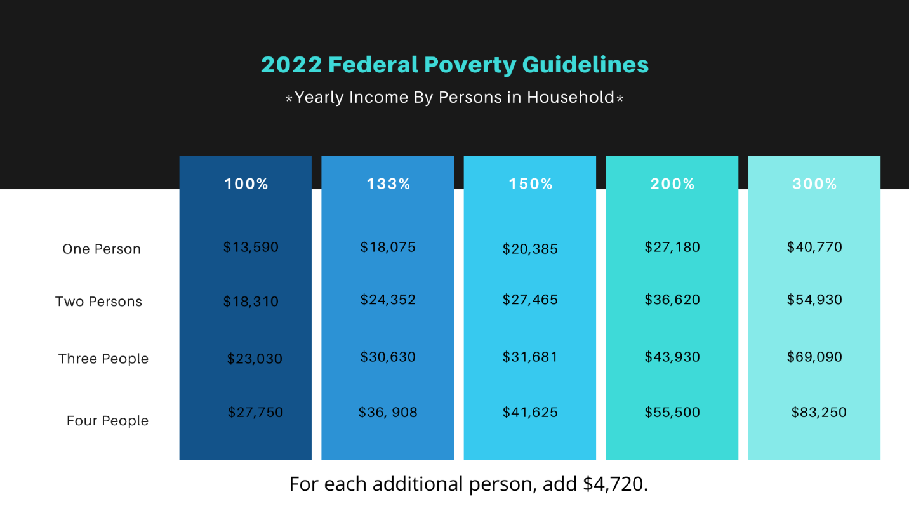
Applicant Agreements
I understand that my participation in the Fresh Bucks program is voluntary. As such, I hereby release, discharge, and hold harmless Community Partnership and Butler City Farmer’s Market program staff, farmers, volunteers, and fellow participants from any and all claims, demands, or causes of action that I may result during the program.
_________ I agree
I do hereby give permission to Community Partnership, Inc. and the Butler City Farmer’s Market, its agents, and others working under its authority, full and free use of video/photographs containing my image/likeness. I understand these images may be used for promotional, news, research, and/or educational purposes. I hereby release, discharge, and hold harmless Community Partnership, Inc. and the Butler City Farmer’s Market and their agents from any and all claims, demands, or causes of action that I may hereafter have by reason of anything contained in the photographs or video. I do further certify that I am either of legal age, or possess full legal capacity to execute the foregoing authorization and release.
________ I agree

All information contained within this application is true and correct to the best of my knowledge.
Signature: ________________________________________________________________________

Applications should be returned to:
Community Partnership
c/o Fresh Bucks Program
127 South Main Street
Butler, Pa 16001

